Class: Final Year B.Tech(Computer Science and Engineering)
Year: 2025-26 Semester: 1
Course: High Performance Computing Lab

Practical No. 3
PRN: 22510033
Name: Jasmine Imtiyaj Sayyad
Batch: B8
Title of practical:
Study and Implementation of schedule, nowait, reduction, ordered and collapse clauses

Problem Statement 1:

Analyse and implement a Parallel code for below program using OpenMP.

// C Program to find the minimum scalar product of two vectors (dot product)

Screenshots:

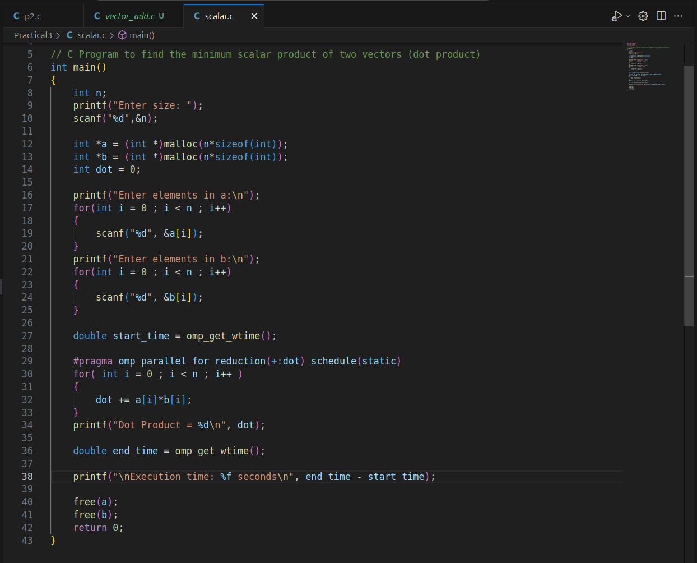

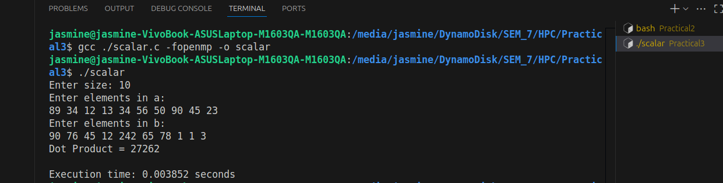Information and analysis:

schedule(type, chunk_size)
Purpose: Controls how loop iterations are divided among threads.
Types:
static: Pre-divides equal chunks (good for balanced workloads).
dynamic: Assigns chunks on-the-fly (good for uneven workloads).
guided: Starts with large chunks, reduces over time.

nowait
Purpose: Removes implicit barrier after the loop, allowing threads to proceed immediately.
Use Case: When next loop doesn’t depend on current results.
reduction(op:var)
Purpose: Combines private copies of var from all threads using op (e.g., +, *, max). Avoids race conditions when accumulating results.
ordered
Purpose: Ensures a block executes in sequential order (rarely needed).
Use Case: When loop iterations must be processed in order.

collapse(n)
Purpose: Parallelizes nested loops by flattening them into a single loop.
Use Case: For nested loops with no dependencies.

Problem Statement 2:

Write OpenMP code for two 2D Matrix addition, vary the size of your matrices from 250, 500, 750, 1000, and 2000 and measure the runtime with one thread (Use functions in C in calculate the execution time or use GPROF)
i. For each matrix size, change the number of threads from 2,4,8., and plot the speedup versus the number of threads.
ii. Explain whether or not the scaling behaviour is as expected.

Screenshots:
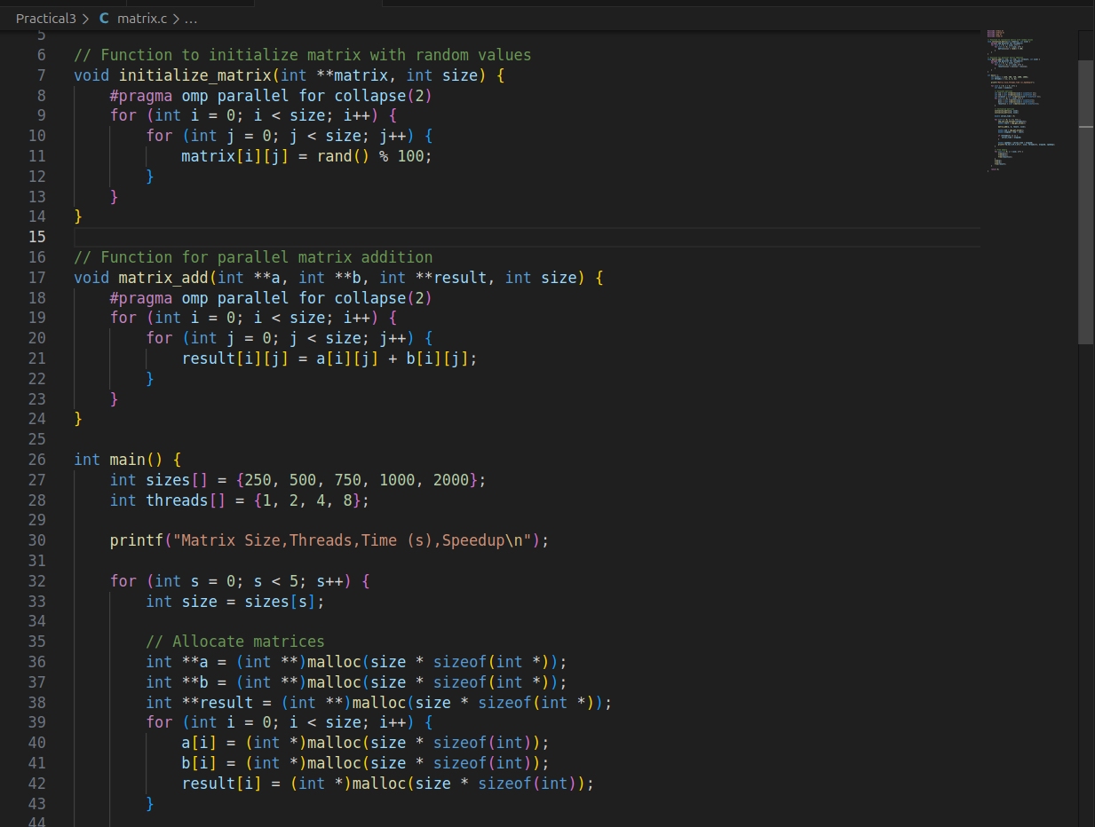
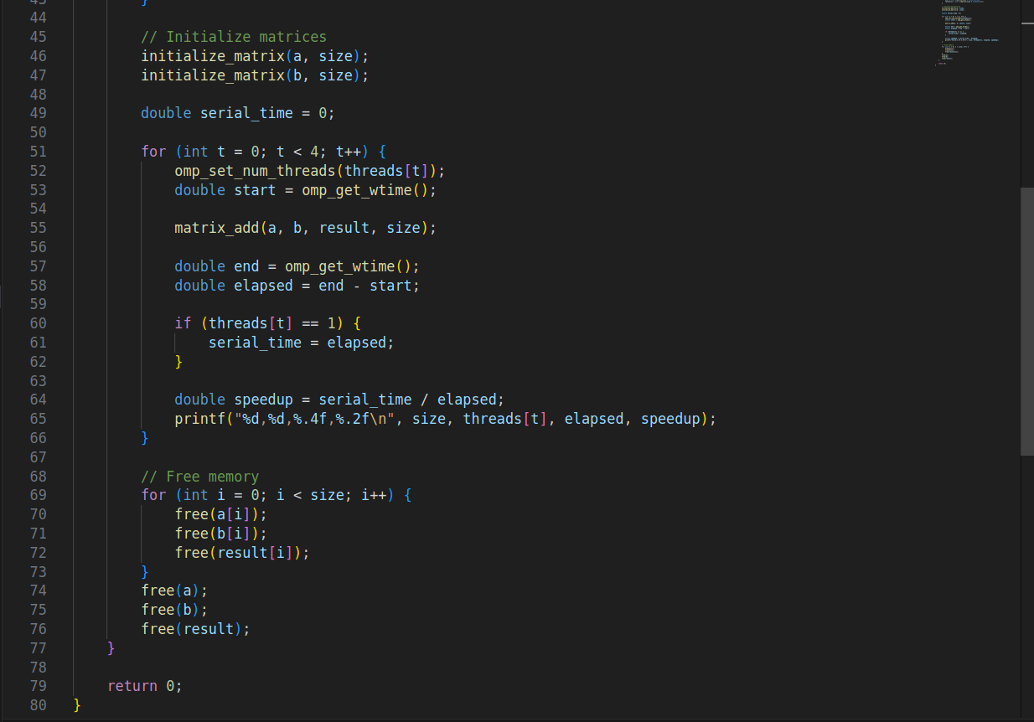
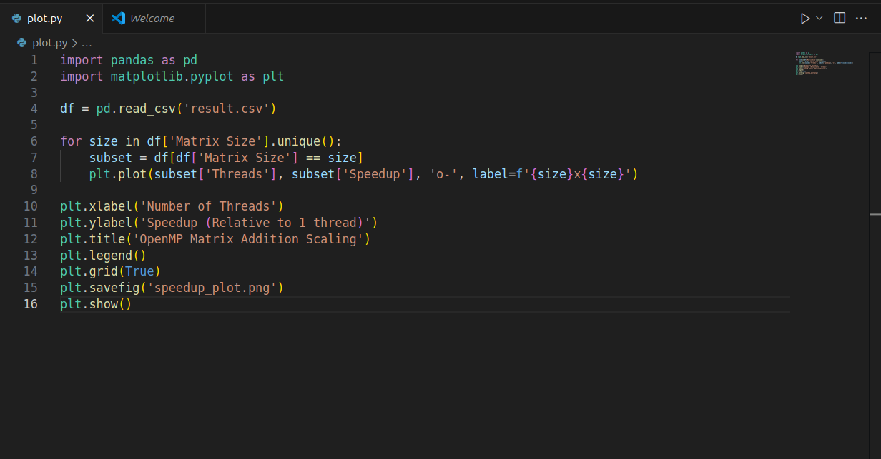

Information and analysis:
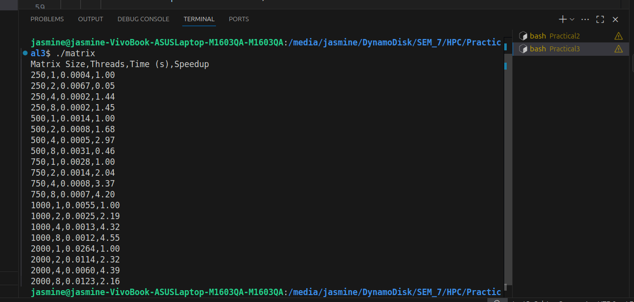

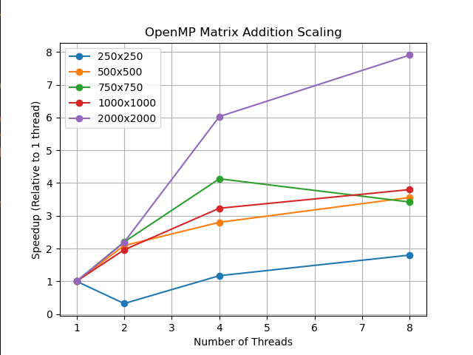

Small Matrices (250×250)
High overhead dominates: Thread setup takes more time than the actual computation.
Limited speedup: Parallel gains can't overcome the fixed costs of going parallel.

2. Medium Matrices (500×750)
Better utilization: More work per thread reduces overhead impact.
Sublinear scaling: Speedup improves but hits memory/cache bottlenecks.

3. Large Matrices (1000×2000)
Computation wins: Work is large enough to mask parallel costs.
Near-linear scaling: More threads = proportional speedup (ideal case).

4. Why Scaling Isn’t Perfect
Parallel overhead: Creating/managing threads isn’t free.
Memory limits: Too many threads fight for memory bandwidth.
Cache issues: Threads may accidentally share cache lines (false sharing).
Load imbalance: Static work splits may leave threads idle.

Problem Statement 3:

For 1D Vector (size=200) and scalar addition, Write a OpenMP code with the following: i. Use STATIC schedule and set the loop iteration chunk size to various sizes when changing the size of your matrix. Analyze the speedup. ii. Use DYNAMIC schedule and set the loop iteration chunk size to various sizes when changing the size of your matrix. Analyze the speedup. iii. Demonstrate the use of nowait clause.

Screenshots:
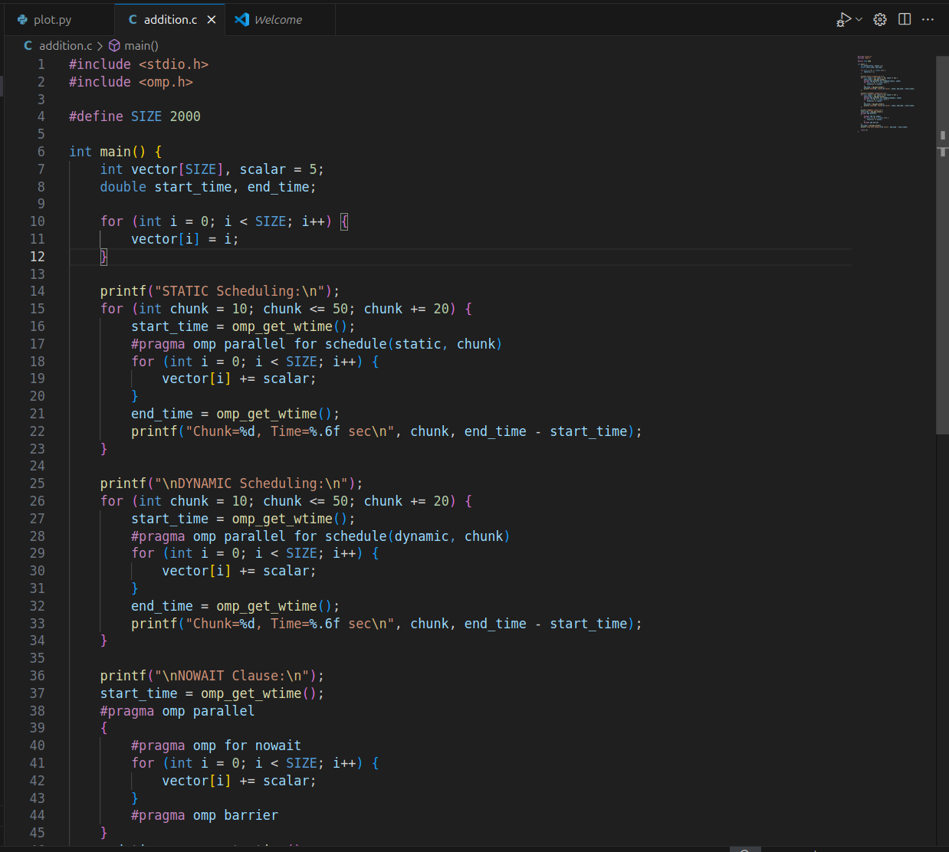

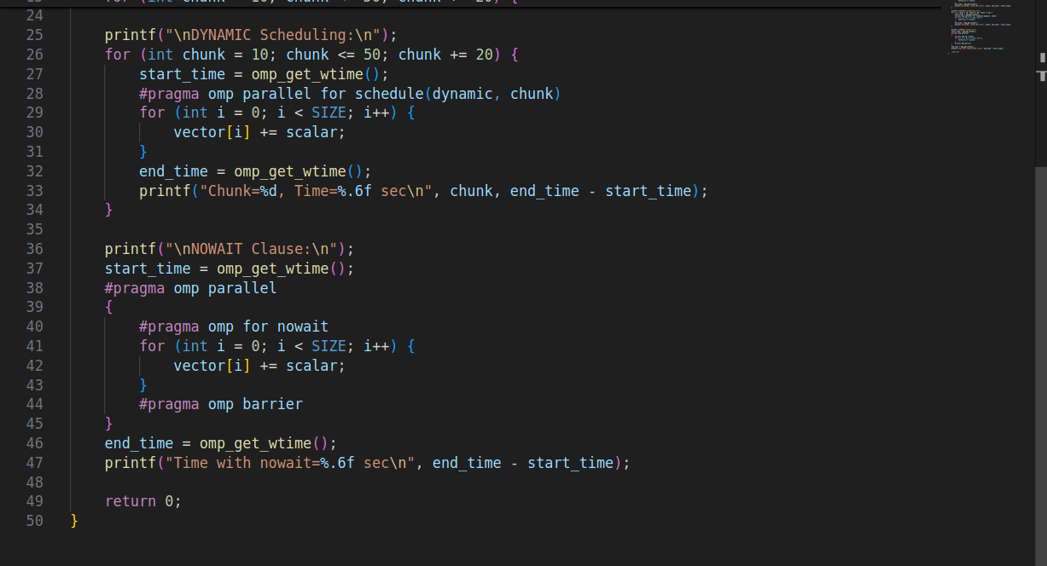

Information and analysis:
1)schedule(static, chunk) →
Static scheduling divides the loop iterations into equal-sized "chunks".
Each thread gets a chunk of iterations before the loop starts.
Example: If SIZE=2000, chunk=10, and 4 threads →
Thread 0: 0–9, 40–49, 80–89…
Thread 1: 10–19, 50–59, 90–99…
chunk varies between 10 and 50 to see how chunk size affects performance

2)schedule(dynamic, chunk) →
Dynamic scheduling assigns chunks at runtime as threads become free.This is better if iterations take unequal time, because idle threads can grab new chunks instead of waiting.
Example:
Thread 0 finishes chunk 0 quickly → immediately takes next chunk.
Thread 1 may still be working on its chunk

#pragma omp for nowait →
Executes the for loop in parallel like before.
"nowait" removes the implicit barrier at the end of the loop.
Normally, threads must wait at the end of the loop until all threads finish.
But with nowait, threads can continue without waiting.
#pragma omp barrier → Explicitly added barrier to synchronize later.
This shows that you can manually control where threads should synchronize.

Github Link:
https://github.com/jasminesayyad29/HPC/tree/Practical3

